**Haier HSU-12LK03E Air Conditioner**

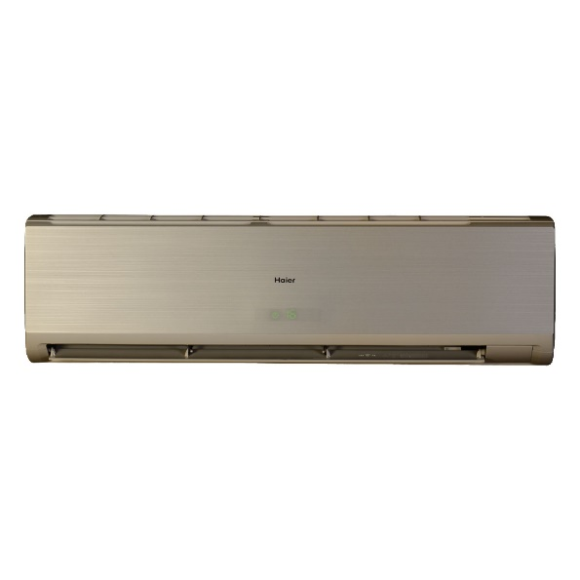

|  |  |  |  |  |  |
| --- | --- | --- | --- | --- | --- |
|  |  | |  |  | |
| **Ton:** | | 1.5 |
| **Fixed or inverter:** | | Fixed Frequency |
| **Cooling Capacity(BTU):** | | 18000 |
| **Air Circulation（m³/h）:** | | 750 |
| **Power Input(W)-Cooling:** | | 1600 |
| **Running Current(A)-Cooling:** | | 7.7 |
| **Power Supply（Ph/V/Hz）:** | | 1,220,50, |
| **EER:** | | 2.73 |
|  | |  |  | |  | |
|  | |  |  | |  | |
|  | | **Indoor Dimension(mm) W/D/H:** | 938/187/265 | |  | |
|  | | **Outdoor Dimension(mm) W/D/H:** | 783/255/543 | |  | |
|  | | **Indoor Weight(kg):** | 10.5 | |  | |
|  | | **Outdoor Weight(kg):** | 37 | |  | |
|  | |  |  | |  | |
|  | | **Compressor:** | Mitsubishi | |  | |
|  | | **Refrigerant:** | R22 | |  | |
|  | | **Refrigerant pipe:** | pure copper | |  | |